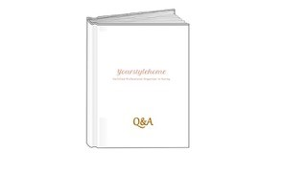 Q&A
How much is a consultation? | Consultations are priced at £20.00 + VAT and planning tools will be supplied to assist in setting your goals and objectives
What is the hourly rate for services? | The hourly rate is priced at £40.00 per hour + VAT
Can I buy my own storage and organising consumables? | Of course, however in some instances we may be able to use what you already have; every client is different and there are a range of items and solutions to explore
What about waste and removal of unwanted items? | Recycling, donating and waste disposal can be arranged with a licensed waste carrier.  Shredding of confidential waste can also be done but additional costs may be incurred for these services
Why do I need a professional and what are the benefits of hiring one? | Reason & Objectivity, Calm Attitude, Fresh Eyes, Maintenance Strategies, Job Completion, Efficiency & Focus
How can I make an appointment? | Either email or telephone to discuss the requirements and services you are considering, and a date and time can be scheduled
I’m not Surrey based can you still help me? | Travel up to 15 miles is free of charge; any trip over 30 miles in total may be charged at 50p per mile.
I’ve got an unusual or bespoke project that isn’t listed as a service offered? | Set up a consultation and we can discuss your needs and draw up a scope of works
The mess is so bad I’m anxious of letting anyone see it? | The worse the mess the bigger the challenge, there is no judgement and therefore no need to worry; just by visiting Your Style Home online you are taking your first steps in taming and organising your home
What if I don’t want to part with any of my belongings or mess; will you still be able to help me? | Yes, just by storing things differently and implementing smart storage solutions we can make positive changes and create a less chaotic environment

